

User manual for CXP00002 test system
  - Subject: Vision product testers

Author: Jonathan Vanden Berk

version | Date | Reviewed by | Approved by
1v2 | 2026-07-31 | … | …

Revision history
Version | Date | Revisions
1v0 | 2026-07-30 | First version – chapter structure defined and filled in with the known CXP00002 information.
1v1 | 2026-07-31 | Added the thermocouple probe taping instruction (bottom side of the socket daughterboard) to §1.3 and §5.2.  Added figures of the tester motherboard, socket daughterboard, FT/ThermoStream setup and waffle pack.  Rebuilt on the official Magics document template.
1v2 | 2026-07-31 | Completed the product description (CoaXPress serialiser, QFN64 9 × 9 mm) and the device orientation instruction (corner dot to socket triangle).  Added the remote-desktop connection and GUI launch procedure, and the TRIM and FT GUI screenshots.  Added §1.4 on preventing damage to the measurement board (supply contacts clear of the isolation mat; 12 V supply to be removed/disabled when switching to module testing).  Filled in the FT temperature points (−40 °C, +85 °C, +25 °C), the REPORT tab description and the reference to mag-cxp-setup-report.  Reviewed by: …  Approved by: …

Table of Contents
Revision history 2
Table of Contents 3
1 Introduction and Safety 5
1.1 Product description 5
1.2 ESD precautions 5
1.3 ThermoStream safety (FT stage only) 5
1.4 Preventing damage to the measurement board 5
1.4.1 Supply contacts must not touch the isolation mat 5
1.4.2 Measurement board supply when switching to module testing 5
1.5 Switching between test stages or databases 6
2 Test system 7
2.1 Hardware configuration overview for component testing 7
2.2 Hardware configuration overview for module testing 8
2.3 Software interface 8
2.3.1 Connecting to the test PC and launching the GUI 8
2.3.2 GUI fields (RUN tab) 8
2.4 Environmental requirements 10
2.4.1 Temperature 10
2.4.2 Cleanliness 10
3 Inputs for batch testing 11
4 Outputs for batch testing 12
5 Procedure for batch testing 13
5.1 Calibration of instruments check 13
5.2 Initialization and power-on of the test system 13
5.3 Executing the test on the first part of the batch 17
5.4 Executing the test on the other parts of the batch 18
5.5 Interpreting results and SW binning 18
5.6 Retest 18
5.7 Recording good devices: Part ID to waffle-pack pocket mapping 18
5.7.1 Waffle pack rules 18
5.7.2 Waffle pack labelling and file naming 19
6 Troubleshooting 21
List of Acronyms 22

Introduction and Safety

Product description
- CXP00002 (device marking MAG-CXP00002-NP) is the Vision-series serialiser chip. It takes the parallel data coming from the imager chip and converts it into a serial stream that follows the CoaXPress standard.
- Package: QFN, 64 pins, outer dimensions 9 × 9 mm.
- CXP00002 devices are ESD sensitive components.

ESD precautions
- Always wear an ESD wrist strap and work at an ESD-safe workstation when handling CXP00002 devices, the socket daughterboard and the waffle packs.
- Handle devices with ESD-safe tweezers only, never with bare fingers.

ThermoStream safety (FT stage only)
The FT test stage uses the ThermoStream for temperature-controlled testing. The TRIM stage runs at ambient temperature and does not use the ThermoStream.
- The ThermoStream head will drop automatically when pressure is released. Keep hands and cables clear of the area underneath the nozzle.
- Watch for icing on the nozzle, bell jar and socket during cold temperature points.
- The ThermoStream head carries a hot surface warning label. Do not touch it during or immediately after a temperature run at high or low temperature.
- Before start of testing a new FT batch, check that the thermocouple probe is securely taped to the bottom side of the socket daughterboard (see §5.2). A probe that has come loose measures air temperature instead of board temperature: the ThermoStream then regulates to the wrong temperature and the run is invalid without any error being reported.

Preventing damage to the measurement board

Supply contacts must not touch the isolation mat
- The supply contacts of the measurement board must not touch the brown isolation mat. Position the board so that the contacts hang over the edge of the mat, clear of its surface.

Measurement board supply when switching to module testing
- When changing the setup from component testing to module testing, the supply of the measurement board must be removed. This is the PSU channel at the top left, at the 12 V level.
- When several modules are tested in sequence, this supply must be disabled manually every time.
- Why this matters: damage to components on the measurement board (TMUX) has been seen before, and is believed to have been caused by this supply channel still being enabled.

Switching between test stages or databases
When switching between test stages (TRIM ↔ FT) or when changing the database name or location:
- Close the GUI window – this terminates the script.
- Relaunch the script and only then select the new test stage.

Also when a batch is tested over multiple days, start each day a new GUI. This will create a new database file. In case a file gets corrupted only one day of work is lost.

Test system

Hardware configuration overview for component testing
- The DUT is mounted in a single-device clamshell socket (HQN6404-05D3-U) on the VisionSeries_Proxima Product Test Socket PCB_V1 daughterboard. This is socket-board testing, not module testing.
- The daughterboard plugs into the motherboard via 2 (stack) connectors and is additionally connected via a coax cable (CXP interface).
- Device orientation – check this before closing the socket. The component has a dot marked in one of its corners. This dot must be aligned with the triangle marking in the test socket (see Figure 2). A device placed in the wrong orientation will not test correctly and may be damaged.
- Power rails (3V3, 5V, 9V, 12V, VDD3V3ANA, PLL, DIG, CAM, …) are brought in on the labelled banana connectors along the bottom edge of the motherboard.
- The connections are documented in mag-cxp-setup-report, in the Socket board section of the Hardware connections chapter:
  - …\Magics Technologies\Product Test Development - MAG-CXP\Documentation\Internal
  - Note: the socket-board connections are different from the connections used for module (VIS PCB) testing. Do not reuse the module wiring for component testing.
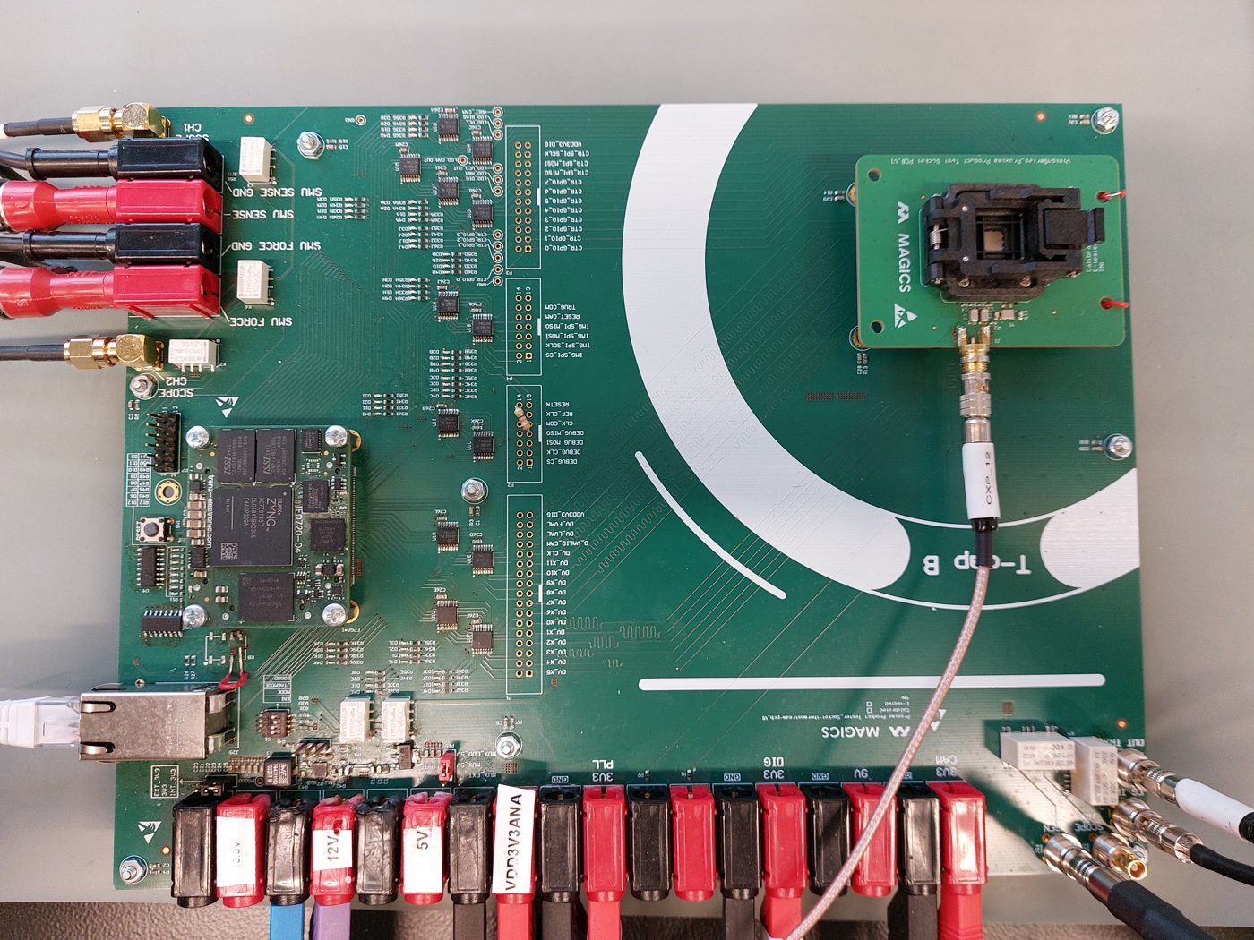
Figure 1: CXP00002 tester overview for component testing.
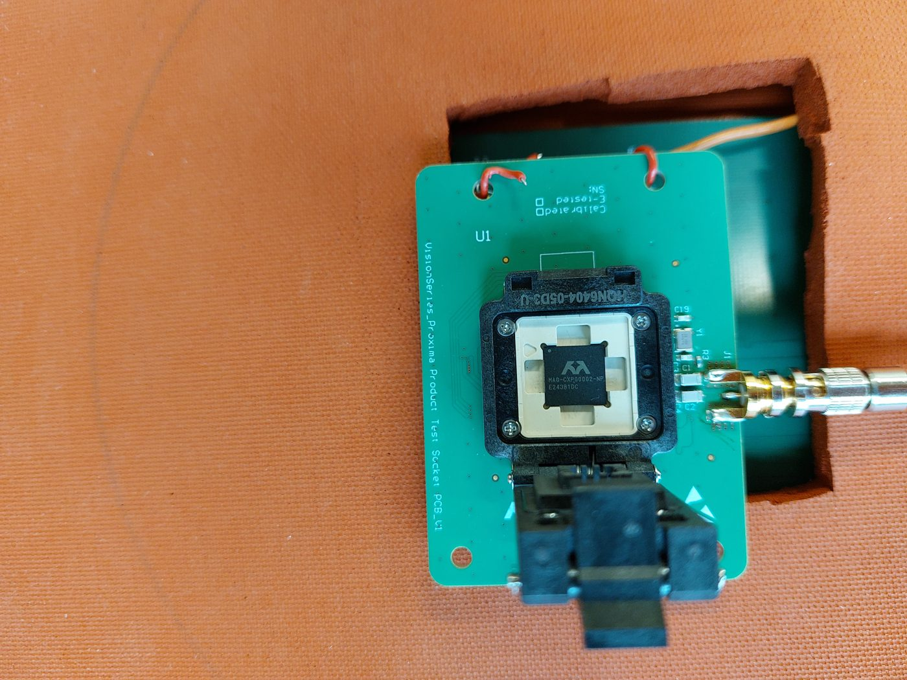
Figure 2: Socket daughterboard close-up with a MAG-CXP00002-NP device loaded in the HQN6404-05D3-U clamshell socket. Note that the probe of the thermostreamer goes to the bottom side of the daughter PCB.

Hardware configuration overview for module testing
Todo

Software interface

Connecting to the test PC and launching the GUI
- Connect to the test PC over Remote Desktop, IP address 10.163.6.27.
- Log in with user name testrack and the test-rack password.
- If the PC has just been rebooted it asks for authentication to create a colour profile. Cancel this prompt – the same question is asked three times.
- Go to the folder ~/production_tester/stable_sw and open a terminal there.
- Check that the working copy is clean by running git status. Do this before launching the GUI, and perform a git pull if the software is not in line with the latest modifications.
- Launch the GUI with: poetry run python tests/run_gui.py
The GUI reports the Git TAG, hash and head state at the start of every run – check that it reads HEAD IN LINE WITH ORIGIN and CLEAN.

GUI fields (RUN tab)
Table 1: Test Application GUI fields on the RUN tab.
Field | Description
Test stage (dropdown) | Select TRIM – production trim test or FT – production final test.
Temperature Control | Checkbox. Leave unchecked for TRIM (ambient). Check for FT (ThermoStream controlled).
Add Guard-Bands | Must be checked for production TRIM and FT runs. Only GRR/characterization runs leave this unchecked.
repetitions | Keep at 1 for production testing. Higher values are only used for test-system characterization.
Database Path | Defaults to .../stable_sw/sw/e_databases/TRIM/data_YYYYMMDD.db or the equivalent FT folder – one database file per day. Normally left at the default.
Part-ID | Unique identifier per device, e.g. S0276. Must be entered before every run.
Progress bar / RUN | Shows live test progress and the test step currently executing. Click RUN to start.
REPORT tab | Gives the operator a quick first glance at the results. Note that it shows median values across different test conditions, so it must be interpreted with that in mind. The detailed analysis of a finished batch is done by product engineering.

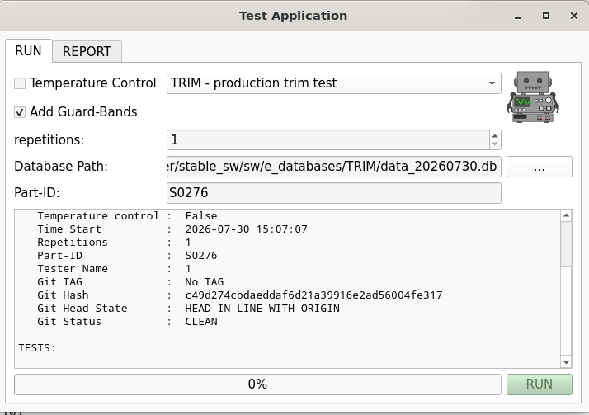
Figure 3: Test Application GUI configured for the TRIM stage: Temperature Control unchecked, Add Guard-Bands checked, repetitions 1.
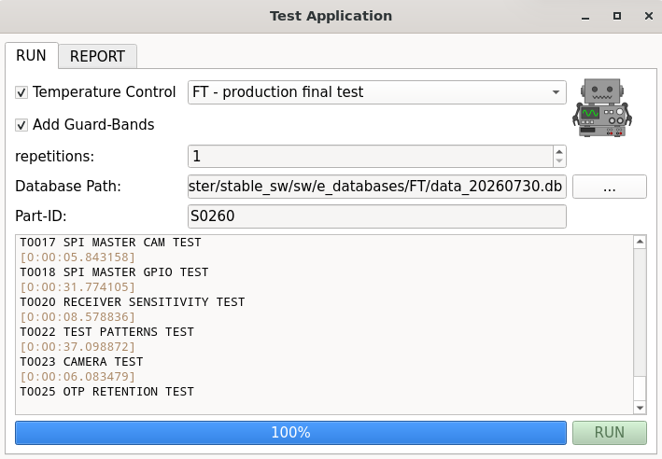
Figure 4: Test Application GUI configured for the FT stage: Temperature Control checked, Add Guard-Bands checked, repetitions 1.

Environmental requirements

Temperature
- TRIM: ambient temperature, no ThermoStream (Temperature Control unchecked).
- FT: ThermoStream temperature control enabled. The temperature points are −40 °C, +85 °C and +25 °C, tested in that order.

Cleanliness
- Check the DUT and the socket for dirt or fingerprints and clean if needed, according to the procedure described in the PM plan.

Inputs for batch testing
- Number of parts to be tested and the list of unique Part IDs to be used.
- Serial ID of batch
- Test stage: TRIM or FT.
- Add Guard-Bands enabled – mandatory for production TRIM and FT.
- Temperature testing: yes or no. For FT the temperature points themselves are fixed – see §2.4.1.
- The SW-bin to HW-bin table from the test plan specification, mag-cxp-product-test-plan – always use the latest revision:
  - …\Magics Technologies\Product Test Development - MAG-CXP\Documentation\Deliverables_in_progress\Test Plan
- Reference sample(s) to be used for the batch (If any).

Outputs for batch testing
- A unique .db database file per day, per test stage (TRIM / FT).
- Operator log file – a table in which the operator records, per part, the resulting SW bin and the database file the part is stored in, together with the date, operator name and test stage. Start from the template T_operator_log_file_CXP00002.xlsx, stored in:
  - …\Magics Technologies\Polaris - Documents\WP9.0_Chip_validation\Product tester results\CXP00002\Part ID to pocket in waffle pack mapper
  - Completed operator log files are handed over to the person responsible for production testing.
- Part ID to waffle-pack pocket mapping files – one file per waffle pack, stored in the same folder as above. Naming convention and rules are described in §5.7.
- For every good device (SW bin 1..99) the operator records the Part ID to waffle-pack pocket mapping – see §5.7.
- At the end of the batch, copy the .db file(s) and the log files to the SharePoint Polaris WP9.0 project folder for CXP00002 (Product tester results).

Procedure for batch testing

Calibration of instruments check
- Verify that all instruments are calibrated. The calibration status is maintained with the scripts in the VISION_equipment_calibration repository: https://github.com/magics-tech/VISION_equipment_calibration.git
- Report any non-calibrated equipment to the tester owner. If there is none, continue with the next step.

Initialization and power-on of the test system
For FT (temperature testing) only:
- Open the pressure valve for the ThermoStream and Power ON the ThermoStream (allow a couple of minutes for its self-calibration routine).
- Tape the thermocouple probe to the bottom side of the socket daughterboard – that is, the side opposite the socket, not the side the socket is mounted on:
- The probe tip must make good, flat contact with the PCB, as close as possible underneath the socket/DUT position. Place a Kapton tape on the PCB to electrically isolate the tip from the ground plane.
- Use high-temperature tape (e.g. Kapton) and make sure the probe cannot work loose during the run.
- The probe must not be pinched between the daughterboard and its support, and must not obstruct the socket lid or the coax connector.
- Check that the daughterboard sits on its insulating foam support and is not touching the nozzle before it lowers.
- Connect the ThermoStream ethernet cable to the switch in the test rack.
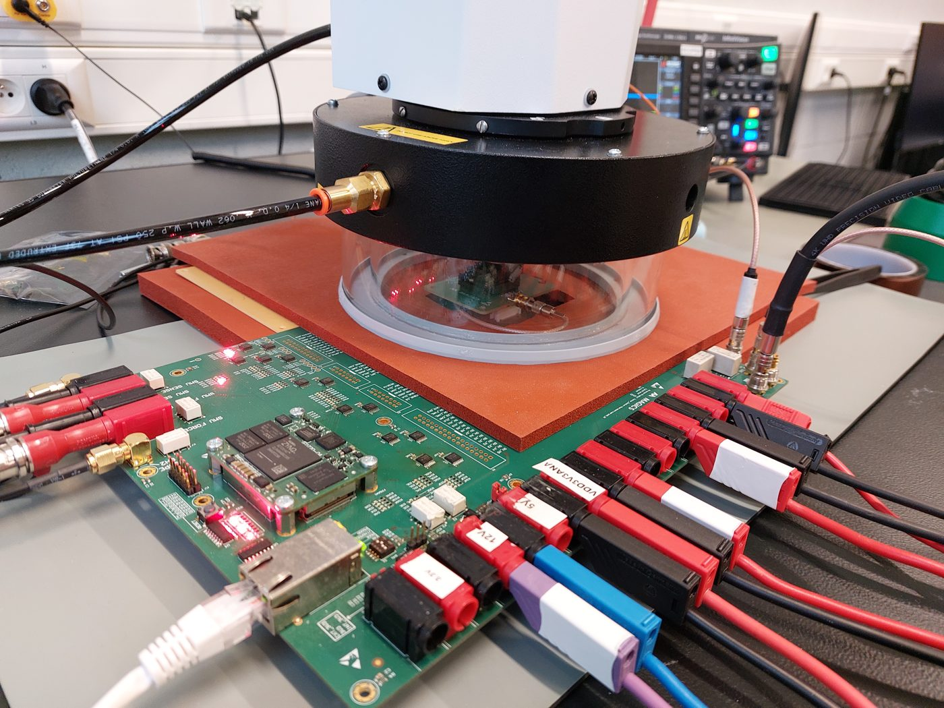
Figure 5: FT setup: ThermoStream bell jar lowered over the socket daughterboard, which sits on the insulating foam above the motherboard.
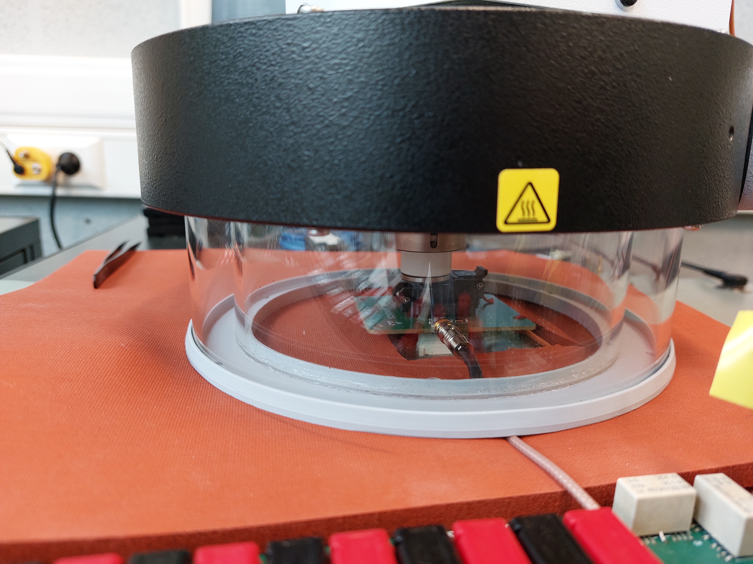
Figure 6: Socket daughterboard inside the ThermoStream enclosure. The thermocouple probe is taped to the bottom side of the daughterboard, i.e. the side opposite the socket.
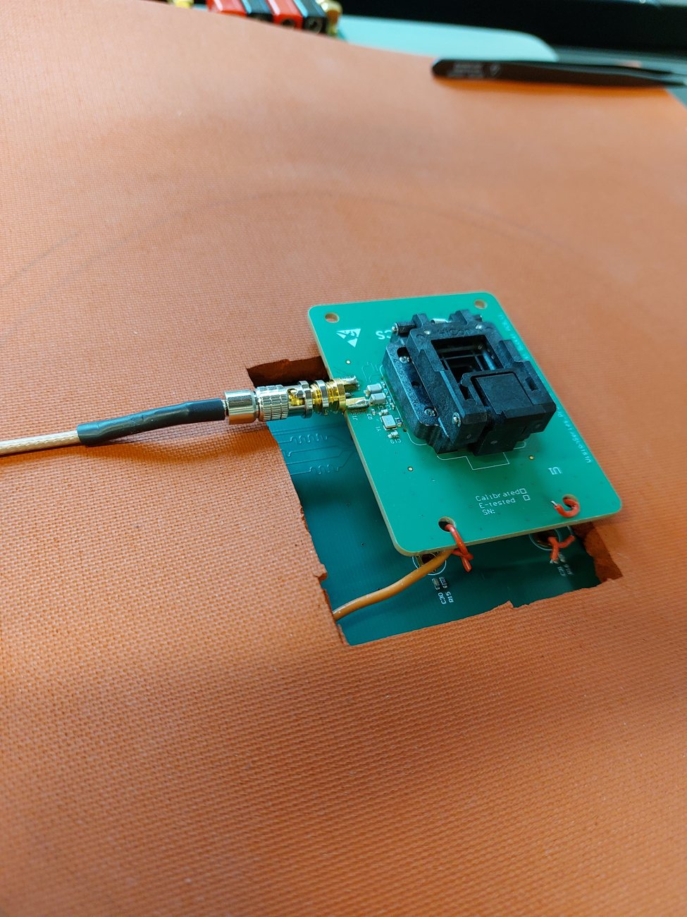
Figure 7: Socket daughterboard placed in the cut-out of the brown isolation mat. The coax (CXP) cable is connected and the thermocouple wire runs to the bottom side of the board.
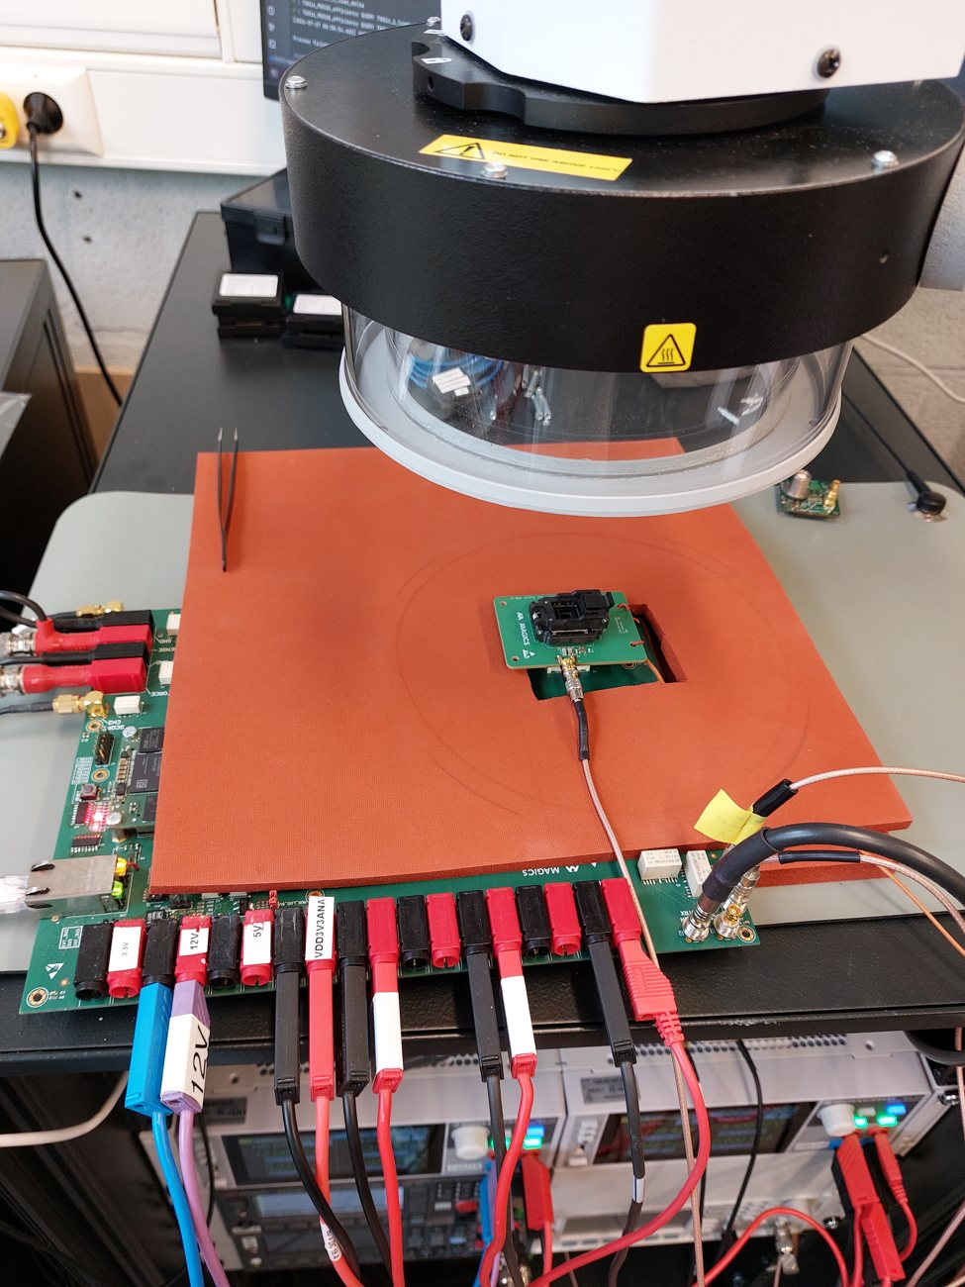
Figure 8: FT setup with the ThermoStream head raised. Note that the supply contacts of the motherboard hang over the edge of the isolation mat (§1.4).
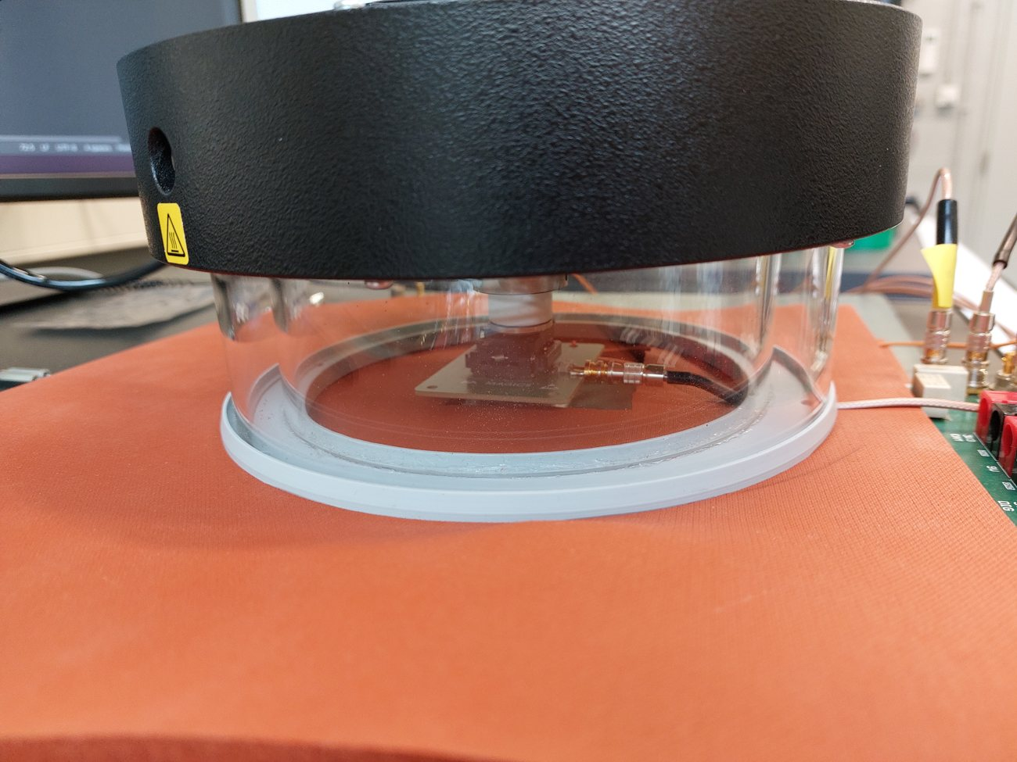
Figure 9: ThermoStream bell jar lowered onto the isolation mat, sealing the socket daughterboard inside.
For all test stages:
- Check that the supply contacts of the measurement board are not touching the brown isolation mat – they must hang over the edge of the mat (§1.4).
- Open the socket clamshell, place the CXP00002 device in the cavity with its corner dot aligned to the triangle marking in the socket (§2.1, Figure 2), and close the socket.
- Check the cabling (power and data):
- Mains power (230 V) is connected to all rack instruments.
- Ethernet / USB cables are properly plugged into each instrument.
- The rack PC is connected to the network and a power source
- The wiring matches the Socket board section of the Hardware connections chapter of mag-cxp-setup-report – not the module (VIS PCB) wiring.
- Log in to the test PC.
- Power ON all instruments in the rack.
- Optional: Perform “experimate net scan” command and check that all instruments are found. If not, see chapter 6.
- Respect a 1 h warm-up time before starting the measurements.

Executing the test on the first part of the batch
- On the rack PC, launch the Test Application GUI (see §2.3.1).
- Fill in the configuration fields in the GUI (see the table in §2.3.2):
- Select the correct test stage: TRIM or FT.
- Set repetitions to 1 for production testing.
- For FT, check Temperature Control; for TRIM leave it unchecked.
- Add Guard-Bands must be checked for both TRIM and FT production runs.
- The database path can normally be left at its default value.
- Enter the correct, unique Part-ID.
- Load the socket with a DUT. For the first part of the batch this is normally a reference sample. Lower the thermostreamer head so the nozzle is just above the test socket.
- Click RUN in GUI to start the test.

Executing the test on the other parts of the batch
- When the previous test finishes, all settings are kept except the Part-ID field, which is cleared. For FT the ThermoStream head does not lifts automatically, this must be done manually.
- Open the socket, remove the tested device, place it in the location for its resulting bin (see §5.7), and insert the next device.
- Close the socket and lower the head again.
- Enter the new Part-ID in the GUI.
- Click RUN again. There is no need to relaunch the script – only the Part-ID changes.

Interpreting results and SW binning
- SW bin 1 to 99 – good / pass: the device is within the defined test limits for all test parameters. Place it in the waffle pack and record its pocket (§5.7).
- SW bin 100 to 199 – retest required (§5.6).
- The meaning of the other SW bin ranges (fail categories) is defined in the test plan specification, mag-cxp-product-test-plan.

Retest
- Devices that fall into SW bin 100–199 must be retested using the correct Part-ID at the end of the batch.
- Only one retest is allowed per device.

Recording good devices: Part ID to waffle-pack pocket mapping
Every device that results in a good / pass SW bin (1..99) must be placed in the waffle pack and its location recorded, for full traceability:
- Place the device in the next available pocket of the MAG-CXP00002-NP waffle pack tray, following the tray fill order: top-left → top-right, row by row, ending bottom-right.
- In the mapping file for that waffle pack, write down the pairing of Part ID ↔ pocket location (row/column or pocket number) for every good device placed in that tray.
- Save the mapping file in the Polaris SharePoint project folder:
  - …\Magics Technologies\Polaris - Documents\WP9.0_Chip_validation\Product tester results\CXP00002\Part ID to pocket in waffle pack mapper
Do not overwrite or delete existing mapping files in that folder. Always create or use the file for the current waffle pack without touching previous entries.

Waffle pack rules
- One batch per waffle pack. Different batches must never be mixed: a waffle pack holds parts of a single serial ID only.
- A tested part is placed in an empty pocket, and its Part ID is noted in the mapping file for that waffle pack.
- When PCB production or sales take a part out of the waffle pack, they strike through its ID in the mapping file.
- Once a waffle pack is empty it can be re-used.

Waffle pack labelling and file naming
- Each waffle pack carries a waffle pack ID label on top. That ID is used as the suffix of the mapping file name.
- The file name starts with the date on which the first part was placed in that waffle pack. When a waffle pack is re-used, the date in the name is updated.
  - Example: 20260731_CXP00002_IDs_bin1_in_waffle_pack_3.xlsx
- The label on top of the waffle pack carries the following fields (see Figure 10):
  - Product-ID – the product, e.g. CXP00002.
  - Serial-ID – the serial ID of the batch in that waffle pack, e.g. E243B1DC.
  - UID – the waffle pack ID. This is the number used as the suffix of the mapping file name.
  - Qty – leave empty for waffle packs used to build stock. Qty is only filled in when the waffle pack is used as the container for CXP00002 chips sold and shipped to a customer.
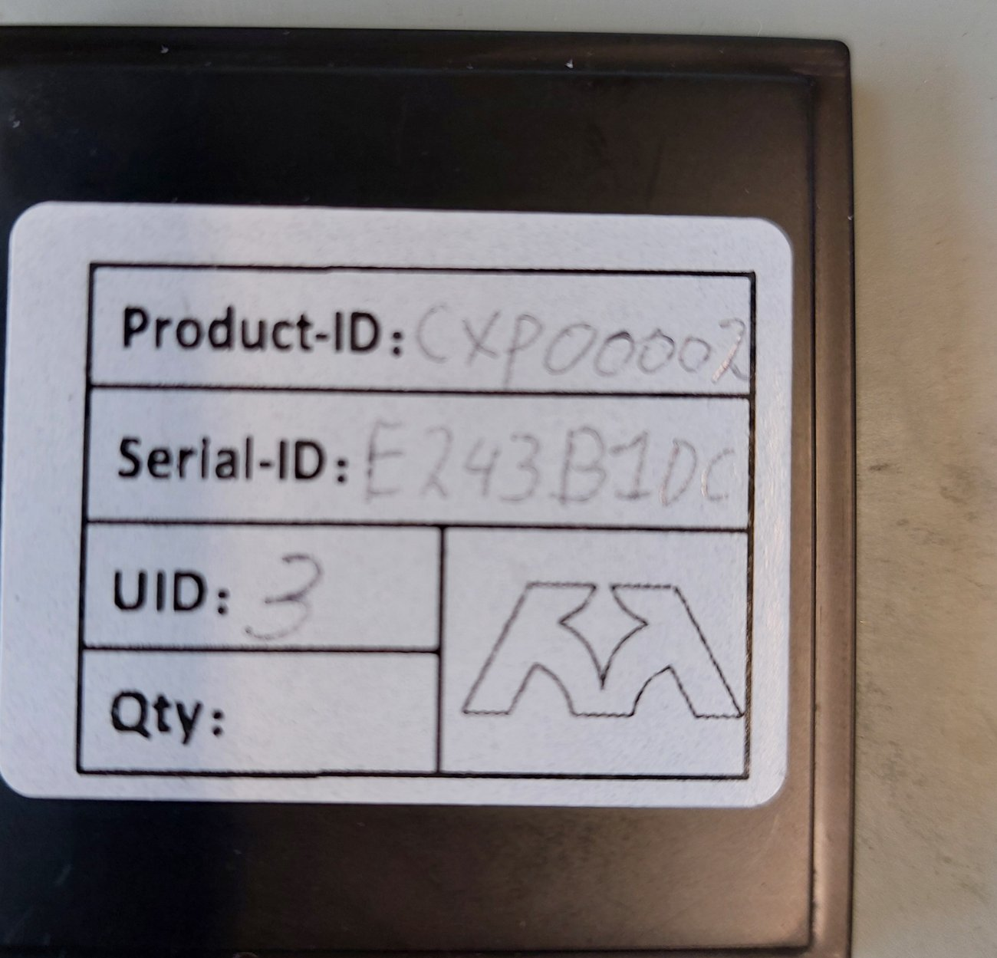
Figure 10: Waffle pack label. Product-ID CXP00002, Serial-ID E243B1DC and UID 3 – this waffle pack corresponds to mapping file 20260731_CXP00002_IDs_bin1_in_waffle_pack_3.xlsx.
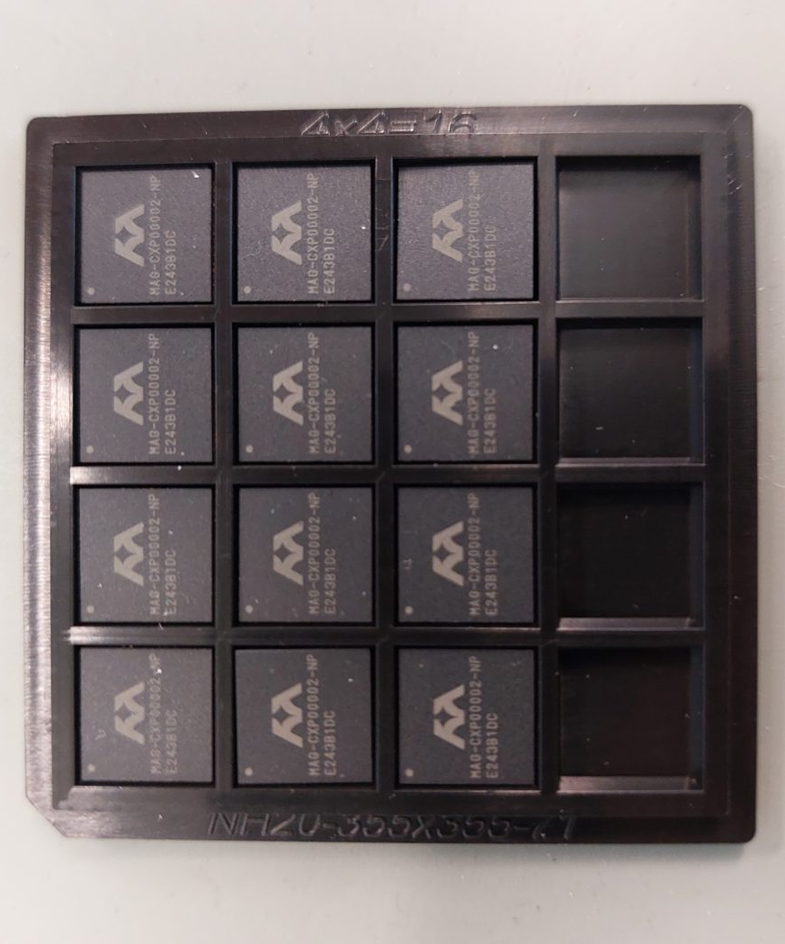
Figure 11: MAG-CXP00002-NP devices in a 4x4 waffle pack tray. Pockets are filled top-left to bottom-right, row by row; the pocket position of every good device must be recorded against its Part ID.

Troubleshooting
- If the script gives an error, make sure all instruments (including the ThermoStream for FT) are visible on the local network:
  - In the PyCharm console or terminal, type experimate net scan.
  - Every expected instrument should be listed in the console.
  - If not, power-cycle the affected instrument(s) and rescan.
- If no air is coming from the ThermoStream while the valve is open, there may be a compressor issue. Contact lab manager.

List of Acronyms
Acronym | Definition
DUT | Device Under Test
FT | Final Test – production test stage, with ThermoStream temperature control
TRIM | Production trim test stage – ambient temperature, no temperature control
GRR | Gauge Repeatability & Reproducibility
HW bin | Hardware bin – physical sorting location for a tested device
SW bin | Software bin – pass / fail / retest result category assigned by the test software
PM plan | Preventive Maintenance plan
DB | Database (.db result file produced by the test software)

